|  |
| --- |
| Logo, company name  Description automatically generatedAIC, MATHEMATICS LEARNING AREA  **YEAR 11 MATHEMATICS APPLICATIONS – UNIT 2**  **Assessment type: Response**  **TASK 9 – TEST 6**  **Applications of trigonometry** |

Student Name: ____________________ ID: __________ Date: _______

**TIME ALLOWED FOR THIS PAPER**

**Reading and Working time for this paper: 50 minutes in class under test conditions**

**MATERIAL REQUIRED FOR THIS PAPER**

*TO BE PROVIDED BY THE SUPERVISOR*

Question/answer booklet.

*TO BE PROVIDED BY THE CANDIDATE*

*Standard Items:* pens, pencils, pencil sharpener, highlighter, eraser, ruler, drawing templates

**IMPORTANT NOTE TO CANDIDATES**

No other items may be taken into the examination room. It is **your** responsibility to ensure that you do not have any unauthorised notes or other items of a non-personal nature in the examination room. If you have any unauthorised material with you, hand it to the supervisor **before** reading any further.

**Structure of this paper**

|  |  |  |  |  |
| --- | --- | --- | --- | --- |
| Section | Number of questions available | Number of questions to be attempted | Suggested working time (minutes) | Marks available |
| **Calculator Assumed** | **7** | **7** | **50** | **42** |
|  | | | **Marks available:** | 42 |
| **Task Weighting** | 7% |

**Instructions to candidates**

* The rules for the conduct of this examination are detailed in the booklet *WACE* *Examinations Handbook*. Sitting this examination implies that you agree to abide by these rules.
* Answer the questions in the spaces provided.
* Spare answer pages can be used. If you need to use them, indicate in the original answer space where the answer is continued.

### SCSA Content – Topic 2.2: Applications of trigonometry

* + 1. Use trigonometric ratios to determine the length of an unknown side, or the size of an unknown angle in a right-angled triangle
    2. Determine the area of a triangle, given two sides and an included angle by using the rule $area=\frac{1}{2} absinC$, or given three sides by using Heron’s rule, and solve related practical problems
    3. Solve problems involving non-right-angled triangles using the sine rule (acute triangles only when determining the size of an angle) and the cosine rule
    4. Solve practical problems involving right-angled and non-right-angled triangles, including problems involving angles of elevation and depression and the use of bearings in navigation

**TO BE AWARDED FULL MARKS ALL WORKING OUT AND CALCULATIONS MUST BE SHOWN**

**Question 1 (4 marks)**

Find the value of the variable in each of the following correct to two decimal places.

(a) (2 marks)

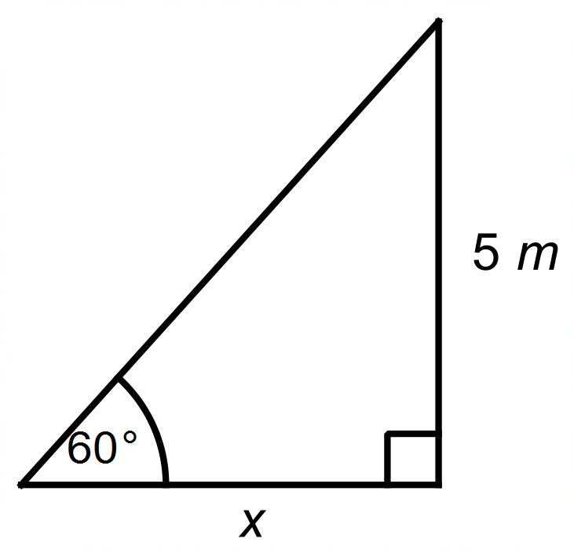

(b) (2 marks)

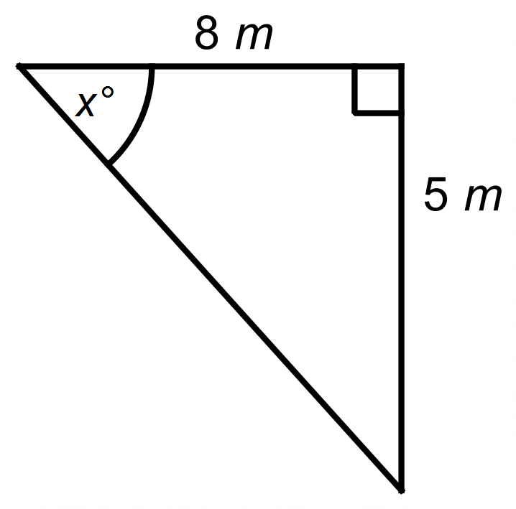

**Question 2 (3 marks)**

From the top of a $38$ m tall building, the angle of depression to a small dog sitting on a path, level with the base of the building, is $23°$.

Sketch a diagram for the given scenario then calculate the distance the dog is from the base of the building.

**Question 3 (9 marks)**

A rocky island is 3 km from a lighthouse on a bearing of 028°T from the base of the lighthouse.

(a) What is the bearing of the lighthouse from the island? (2 marks)

Joel sends a drone from the lighthouse to the island, then to a point, *X*, which is 4.2 km from

the island on a bearing of 120°T from the island.

(b) Complete the diagram of the situation. (2 marks)

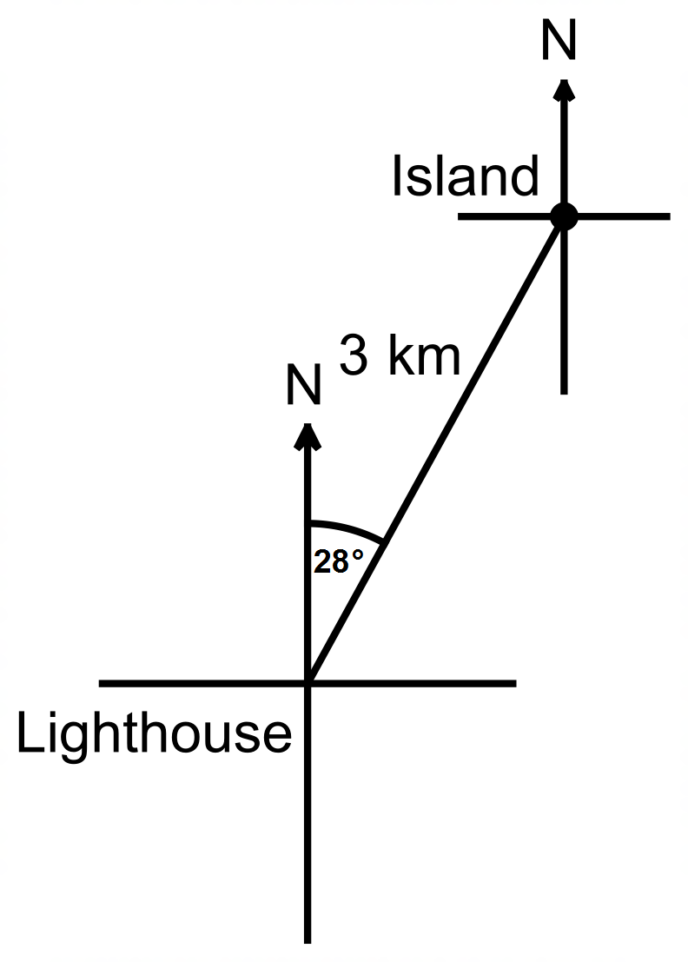



(c) Show, using the cosine rule, that the drone is now 5.075 km from the lighthouse. (2 marks)

(d) It is known that the bearing of the drone from the lighthouse is less than 90°.

Use the sine rule to determine that bearing, correct to the nearest degree. (3 marks)

**Question 4 (7 marks)**

Two bushwalkers set out on an expedition. From the Base Camp, walker A

walks on a bearing of 35°T and walks for a distance of 35km and walker B

walks on a bearing of 155°T and walks for a distance of 42km.

(a) Determine how far the walkers are from each other to the nearest

hundred metres. (3 marks)

(b) On what bearing does walker A have to travel to reach walker B,

correct to the nearest degree. (2 marks)

(c) Determine the area of land, to the nearest square kilometre, the

walkers’ paths have enclosed. (2 marks)

**Question 5 (4 marks)**

A 12-metre pole has been placed in the ground with 9.8 metres of the pole above the ground. To hold the pole in place two guy wires are attached. Guy wire 1 is attached a distance from the top of the pole, while guy wire 2 is attached to the top of the pole. Both guy wires are attached to pegs in the ground, that are an equal distance either side of the pole. The distance between the pegs is 12.64 metres as shown in the diagram below.

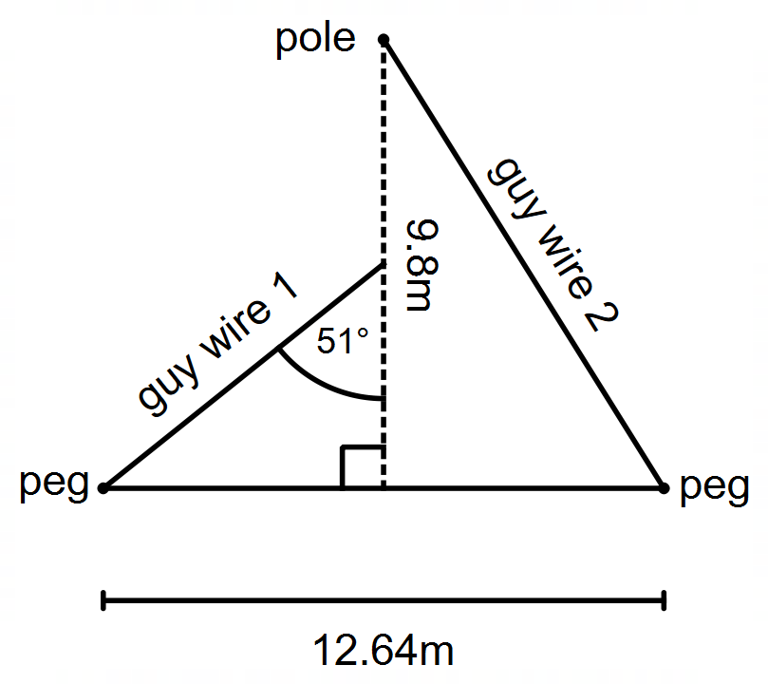

(a) Determine the length of guy wire 1, correct to the nearest metre. (2 marks)

(b) Determine the angle of depression of guy wire 2 from the top of the pole

to the peg on the ground, correct to the nearest degree. (2 marks)

**Question 6 (8 marks)**

The top of a vertical pole $T$ stands $6.4 \text{m}$ above a surrounding level playing field. The angle of depression from $T$ to a small animal at $A$ is $32°$. The animal leaves $A$, moves directly towards the base of the pole $B$ and stops at $C$ (before reaching $B$). The distance $BC$ is $5.5 \text{m}$.

(a) Sketch a diagram to show the above information. (2 marks)

(b) Calculate the line of sight distance from the top of the pole to $A$. (2 marks)

(c) Determine the angle of depression from $T$ to $C$. (2 marks)

(d) Calculate the distance travelled by the animal from $A$ to $C$. (2 marks)

**Question 7 (7 marks)**

The following diagram represents a design for a garden bed in the local park (Not drawn to scale).

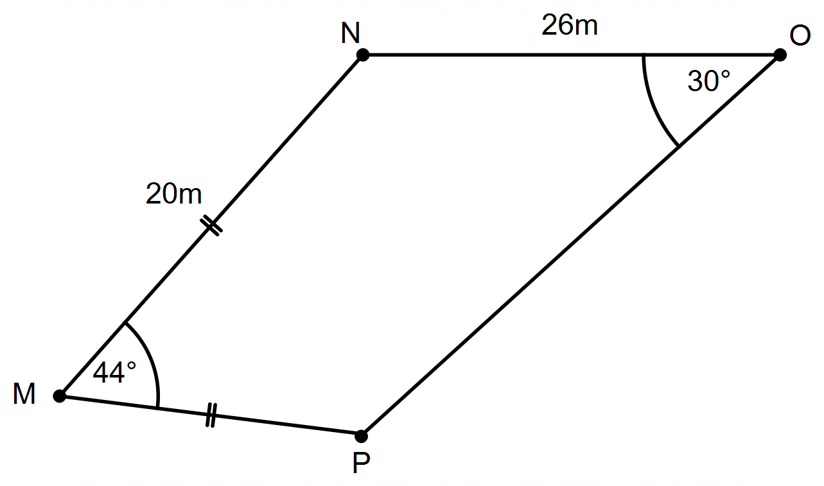

(a) Show that the length of PN is 15 metres, to the nearest metre. (2 marks)

(b) Use your answer from (a) to determine the size of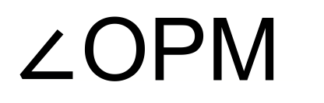to the nearest degree.

(3 marks)

(c) If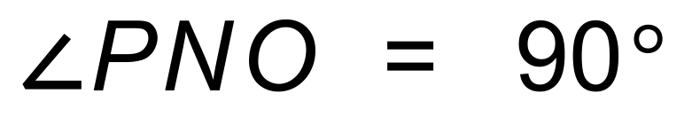 determine the length of PO to the nearest metre. (2 marks)

**Extra working space**